Dictionary Management
> Problem Statement:

The captions and messages, which we call "dictionary", used in our products
are now in state of confusion.

There're so many products, for example HR series has 3 products,
that is, CJK, CWS and CSR, and each product has their own way
to manage the captions and messages. That means each product
has their own database table, and each has different key columns.
And adding to that, lack of sufficient communication with each other
caused the situation that some "dictionaries"are slight different
between the products.

And what is worse, WAP has been heading for global market and
each product separatedly tried to translate their "dictionaries"
in some way. Some products decided to asked a company to translate
their "dictionaries", other products tried to translate their "dictionaries"
on their own, using developers who know the product well.

Against this confused state, we wants you:
- to unify each "dictionaries"
- make it easy for everyone in every department(**) to use "dictionary" data

(**) e.g. sales, consultants and of course development departments

> Solution:

The solution is to create a tool that will be used by the translator/developer to translate the data in speedy, consistent and correct manner. This solution will provide the translators/developers the suggestion based on the previous translations history and department wise translation history.

> Why do we need this solution :

As per the current scenario there is no any tool for the translators/developers to translate the table. They have to manually do this thing in the csv file. Translators/developers have to think about the translation on their own and it takes time. The translation may not be consistent throughout the product as same words or sentences can have different translations.

Ex. フィニッシュ仕事 can have three meanings FINISH JOB, FINISH WORK, COMPLETE TASK.
So if translator do not take care of this thing, same sentence can have different translations.

Till now the translation job is given to some companies. They take a lot of money. But if this tool is successfully implemented, our company can translate its product on its own. So can save money.

> How we can do it:->

We are showing the google translate suggestion and history based suggestions. The basic idea is to keep track of all translations that have been done by creating a translation history database, to process them and create suggestions for some query. Maintaining a query history and related suggestions table, to retrieve the results faster if same query is made again. We can prioritize the suggestions by keeping track of number of occurrence of each suggestion. This can be done in more specific manner by storing the no. of occurrence of suggestion in particular dept. and product.

> Requirements of the system:

    - A server with some space: The system will require the server space to keep all the
previous translations, query table, suggestion table. And it will also have to perform processing required to create suggestion form history of translations. It will also fetch google suggestions.
    - A local system with network connection : The user would need a local system with internet connection, so that the system can exchange data with the server. And it will also need the internet connection to fetch suggestions from google.
    - An active google developer account: The google suggestions will be fetched from translation apis, so we need an active developer account with billing activated.

> Merits of the system:

1.
Business before:
There was no any system for translation. It was either given to some other companies or done by the developers who knew the product well manually.

Business after:
We have created a system that provides an interface to manage all function related to translate a table. Our system will work simply as inputting the table, translating every entry and outputting/exporting the resultant table present in the same structure as per original table.

2.
Business before:
The translation process was slower previously because the translator has to create each translations by his own thinking.

Business after:
In out tool we provided the google and history based suggestions that makes this process much faster.

3.
Business before:
In some cases the translations were inconsistent as there can be many different translations of the same sentence or word in two different languages.

Business after:
we have prioritized our suggestions in a such way that it will show all the different translations and their frequency for a same query or sentence. We have even prioritized it for showing the suggestion frequencies for particular department or product manner. This makes sure that translations are consistent throughout the process.

> How we guaranty the correctness of our system :

After finishing each module of our system, we will write tests for the respective module, to check if it works fine. We will also write tests to ensure that this module doesn't affect the other modules.

After we develop the complete system, we will write tests for the whole system. We will follow the method of regression testing, to ensure that the changes that we include to fix the current bug, doesn't introduce new bugs.

> Detailed explanations and merits of all the functions:-

FUNCTIONS:

- LoadData (Priority : Low): we will have to load the text to be translated from the table file.

- We will ask user the format of the file as it can be present in two formats. Ex. One table per language – format 1 and all languages in single table – format 2.
- After that user will choose the file.
- We must know the text column and its language in order to access the entries and provide particular suggestions.
- We will also have to know the language in which we have to translate the data to.
- After that the department and product of the table should be taken into account because they will be necessary for prioritizing suggestions.
- In format 2 we will have to know two more things that are the translation column and the language column.

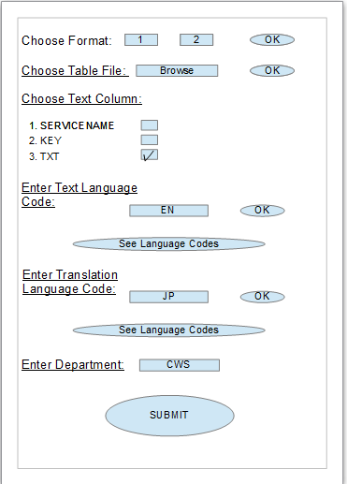
Merits: This method will provide us all the necessary information required about the table, which will enable us to access each entry, to provide the suggestion and to create the final result in the form of the same structured file.

- LoadHistorySuggestions (Priority : High):

- First user will have to mark the text for which he wants the suggestion. This will be make a query to load suggestions.
- In server we will have three tables
1 – Complete history table which will contain all the texts and the translations done before. It will consist of Text, TranslatedText, product, department columns.
2 – Query Table which will contain all the queries previously made. So if the newly made query matches the entry in this table, we can directly show the suggestions as this table will point to suggestion table.
3 – Suggestion table will store suggestions for all previously done queries. Query table will point to this table in order to retrieve suggestion for some already existing query.
- we will load historysuggestions in 2 parts.
- Part 1 will consist of checking if the query done is present in query table or not. If it is present we can simply show all the suggestions mentioned in the query table.
- Part 2 – If the query is not present we will have to find the suggestions for the query by processing on history table. The method that will process the history table and load the suggestion is known as LoadSuggestionsFromHistory method.
- This method will find all the entries in history table for which Text column contains the query string as substring. And then we will find the Common string from the respective TranslatedText column entries. These will be our suggestions for query. We will also note the frequency of the suggestions as per the department and the product.
- We will update the query and suggestion table as we have found new suggestion for new query.
- This method will finally provide us the list of suggestion for some specific query.

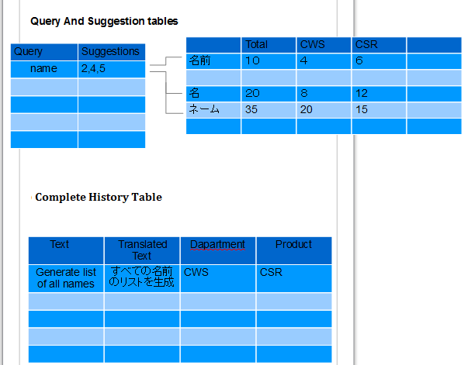
Merits: Query table and suggestion table will provide us fast response to query if it is already present. This will save a lot of computation.

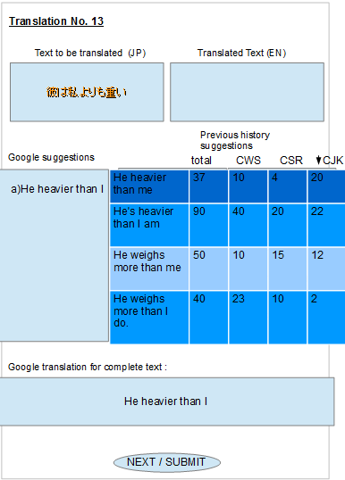
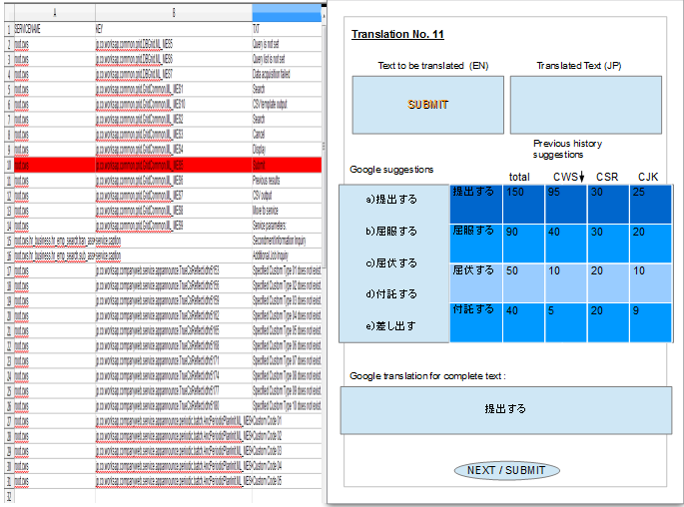
- MegaHitsSuggestions: (Priority : High):
- Here translator is marking the text for which he wants to have suggestions for. So to make his job more easier we can show him the Mega hit suggestions if we get some suggestions for text greater than 1/3rd of the query strings length, occurring more than some specific threshold.
- The threshold values are generally high so that these suggestions can be used as the sure translation of the part of the query string.
- If we get more than one mega hits then we can choose them in such way that the maximum length of the string get covered.
- The reason for not choosing the small length of strings is, the complexity of the calculations will be too high for small characters or words because.
Example: if we are finding the mega hit suggestion for space character or single letter and it can be present in most of the strings, so it might take too much calculation as the string processing is costly. This is because we will have to find all the common string in the translation sentences where ever the space occurs in Text part.

Merits: This will make the translators job very very easy, as if he get mega hit then major part of the string will be already translated for him.

- LoadGoogleSuggestions (Priority : Medium):

- This method is pretty straight forward as we will simply make a query to google apis to load suggestion and whole translation. The suggestions will be loaded only if user marks a single word.
- The whole translation of the string is loaded to show user the google translation to give him the abstract idea about the translated text.

Merits: An abstract idea to translator will be provided to make him think fast. This suggestions will be useful if the suggestion to current query from the history suggestions are not present.
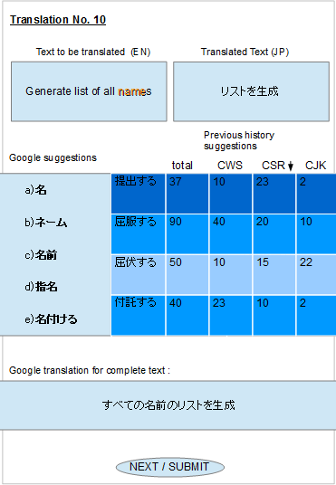
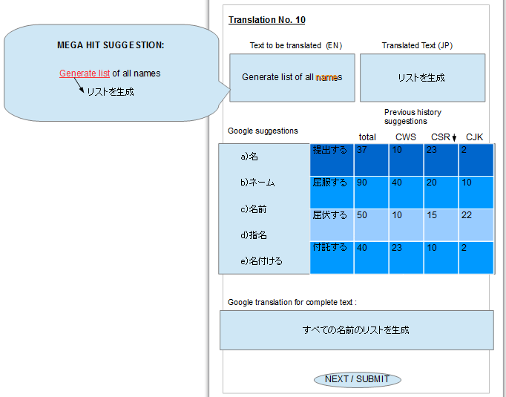

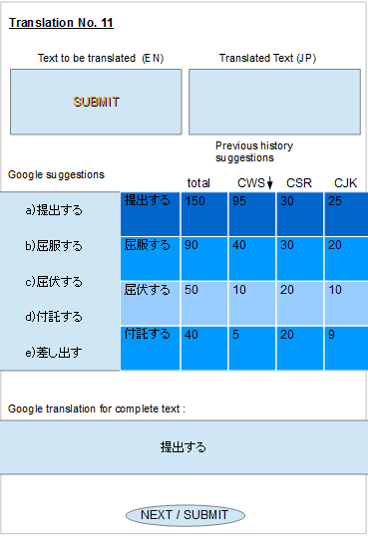

- CompleteUpdate (Priority : High):

- As the whole table gets translated, we will add all the translations to HistoryTable.
- As the new entries are added we will have to update the suggestions frequencies. As many suggestions can be present in these entries.

Merits: This will keep all our databases updated for the next translation.

- ExportResults (Priority : Medium):

- After completing all translations, we will create a new table copy all data with respect to new language. And simply export it. The result will be exported in the same format and structure as the input file is present. For example if the format of the input file is no.1 then, the separate file will be generated for the language in which we have translated our data to. Only the TXT field will be replaced with the corresponding language.

Merits: This method will generate the table in same structure as of before. So translator can submit it into the all language database for that product.

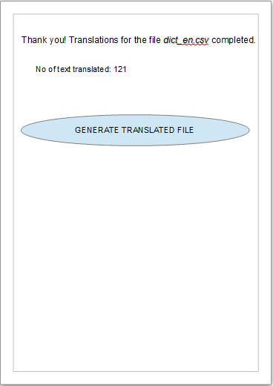

Thank you
Shubham Satish Baldava

Works Applications Co. Ltd.
COMPANY Web Service
Software Engineering Interns

